Visual Erasable Card Based on NFC Technology
Group: 50
EBU5606 Product Development and Marketing
Group Members:
Yuchi Wang , 200978741, 2020213252
Fei Luo, 200978279, 2020213279
Boyang He, 200977342, 2020213253
Junfeng Zhang, 200984328, 2020213271
Hexi Zou, 200980010, 2020213272
Report Word Count: 3229

Table of Contents
Summary of Responsibilities 3
Individual Member 1 (Group Leader) Contribution: <Yuchi Wang> 3
Individual Member 2 Contribution: <Fei Luo> 3
Individual Member 3 Contribution: <Boyang He> 3
Individual Member 4 Contribution: <Junfeng Zhang> 3
Individual Member 5 Contribution: <Hexi Zou> 3
Introduction 4
Opportunity Identification 5
Step 1: Establish a charter 5
Step 2: Generate and sense many opportunities 5
Step 3: Screen opportunities 5
Step 4: Develop promising opportunities 5
Step 5: Select exceptional opportunities 5
Step 6: Reflect on the result and process 7
Mission Statement 8
Identification of Customer Needs 10
Step 1: Gather raw data 10
Step 2: Interpret raw data in terms of customer needs 12
Step 3: Organize the needs into a hierarchy 12
Step4: Establish the relative importance of the needs 13
Step5: Reflect on the results and process 13
Concept Generation and Testing 14
Concept Generation 14
Concept Testing 18
Conclusion 19
List of References 20
Appendix 21
Coursework Meeting Logbook 24

Summary of Responsibilities

Individual Member 1 (Group Leader) Contribution: <Yuchi Wang>

1.Arrange the division of work in the group;
2.Finish the mission statement section P8;
3.Finish the conclusion section P19;

Individual Member 2 Contribution: <Fei Luo>

1.Finish the identification of customers need section P10;
2.Finish the concept generation and testing section P14;
3.Design the questionnaire;

Individual Member 3 Contribution: <Boyang He>

1.Provide the inspiration of the product and research product technology;
2.Sort out the questionnaire data and make it into appendix P21;
3.Organize the references section P20;

Individual Member 4 Contribution: <Junfeng Zhang>

1.Finish the introduction section P4;
2.As the Secretary, organize the meeting materials in the group P24;
3.Finish the typesetting and sorting of the report;

Individual Member 5 Contribution: <Hexi Zou>

1.Finish the opportunity identification section P5;
2. Assist in product design.

Introduction

With the rapid development of science and technology in the 21st century, magnetic cards such as bank cards, metro cards and campus cards have become a rigid demand in people's lives. However, more and more magnetic cards bring people difficulties in using and managing them, confusion, omission cards and other problems have caused people trouble in life. In this context, our team is committed to the development of a multi-functional visual erasable card. We combine all the functions of the customer's magnetic cards into one Multifunctional Card (MFC) based on NFC technology.

Opportunity Identification

In order to better identify opportunities, we use Ulrich and Eppinger’s six-steps process here.

Step 1: Establish a charter
Our task is to develop a small erasable card, which we can launch to the university through our own channels in about a year.

Step 2: Generate and sense many opportunities
This opportunity was created by our teammates through the needs of these universities. Contemporary college students need a convenient item, which has multi-functional uses in school. So we came up with the idea of making portable small erasable NFC card. White-collar workers in the workplace need multi-functional cards to verify their identity and perform a series of tasks. Ordinary workers also need multifunctional cards for eating, swiping cards and access control. Not only that, but the hotel staff also needs to use multi-functional cards for opening doors, verifying their identity and so on. From this point of view, multi-functional cards have a good space for development.

Step 3: Screen opportunities
After analysing and screening the above opportunities, we believe that the multi-function card is more useful in the field of university students and hotel staff, and it is easier to have an immediate effect. Because we can't be sure that all companies need multifunctional cards to keep the company up and running. They may have alternative methods. All students at the university generally need to use the campus card, and the hotel staff need to use the room card. Multi-function cards are more useful for both groups.

Step 4: Develop promising opportunities
Through the above screening, we target students and hotel staff. First, we conduct an external search and investigate the product network. Then, conduct internal search, because application development should timely meet the diversified needs of users and protect users' privacy. The third is to carry out systematic exploration, that is, through the analysis of their own life examples, reasonably promote the use of cards from small groups to large groups, preliminarily judge the personal design innovation of project cards by using certain supply and demand knowledge, and preliminarily simulate the technical feasibility and market product feasibility of the project. Finally, we reflect on solutions and processes, conduct market research, listen to insiders, and use charts and other methods to collect useful information. Discuss the collected data again.

Step 5: Select exceptional opportunities
Through the analysis of the data collected in the previous step, we finally come to the conclusion that our most outstanding opportunity is to promote multi-function cards among college students.
We plan to first promote our products within the scope of Beijing University of Posts and telecommunications, first meet the needs of most students of Beijing University of Posts and telecommunications, and then increase production and improve.
Therefore, we use the r-w-w (Wikipedia, 2022. Near-field communication). framework to analyse it. We divide the specific problems into three main parts, and discuss some small problems in each big problem. Finally, we get some results of these problems.
Real?
Question | Answer
Does there have a market demand? (What's the market demand? How is it satisfied in the past?) | Yes
Does there have some university purchase it? (market size, consumer decision-making process) | Yes
Does the university are willing to buy it? (estimated risk and return, expected price and demand) | Yes
Can the concept be transformed into a product? (How big is the possibility?) | Yes
Does the product meet the requirements in social, legal and environmental regulations? | Yes
Is the product feasible? (Can it be made? Is technology feasible? Can the demand be met?) | Yes
Do our products meet the requirements of the university? (Is there an advantage over other products?) | Yes
Can products be manufactured under the low-cost investment? | Yes
Is the possible risk of the product within the university's enduring scope? | Yes

So, the first ‘real’ problem’s answer is yes.
Win?
Question | Answer
Is there a competitive advantage in the product? | Yes
Is the competitive advantage sustainable? (performance, patents, barriers to entry, alternatives and prices, etc.) | Yes
Is it right to develop the time? | Yes
Is the product consistent with our brand? | Yes
Can we win in the competition? (how much will the other increase? Price changes and new competitors, etc.） | Yes
Are there any advanced resources? (Engineering, finance, sales, production, in line with core competitiveness) | Yes
Is there a successful management? (experience and opportunity) | Yes
Is it the same as competitors or better understanding of the market than they do? (consumer behaviour, channels) | Yes

So, the second ’win’ problem’s answer is yes.
Worth?
Question | Answer
Will it bring profit? | Yes
Do we have enough resources and funds to develop? | Yes
Can we bear the corresponding risk? (what's going to be a problem? Technical risk, market risk) | Yes
Is it consistent with our strategy? (in line with the direction of development, brand influence and implied options) | Yes

So, the third ’worth’ problem’s answer is yes.

Step 6: Reflect on the result and process
With the answers to the above three parts, we think the new product is very good and can reduce the cost fully, making it easier for schools to accept our products. The use of innovation allows users to have a more comfortable experience. So we finally decide to use this plan. In the process of our choice, although there are many feasible directions to choose. But we have to choose the best way for ourselves.

Mission Statement

Multifunctional Card (MFC) Mission Statement
Product Description
·Visual erasable card based on NFC technology which can integrate the functions of various magnetic cards
Key Business Goals (Bilibili, 2022. Mini Smart NFC Card )
·Solve the problem that people carry all kinds of magnetic cards when they go out, which is easy to be confused and lost
·Make the magnetic card itself can modify permissions at any time. Adding or reducing one permission at any time will not affect the normal operation of other permissions
·Add as much information as possible to a portable card to maximize its application efficiency
·The display content can be set on the ink screen through application
·Environmentally-friendly products
Primary Market
·People who need to go back and forth to and from various access control places, or people who hold a variety of membership cards, bus cards and others
Secondary Markets
·Various types of card handling institutions
·Research institutions developing innovative card functions
Assumptions and Constraints
·Card Durability
·Technology for multifunctional cards
·Technology of reading card through NFC technology and modifying it through app
·Maintain card security, independence and privacy
·Public acceptance of emerging products
Stakeholders
·Purchasers and Users
·Service Operations
·Distributors and Resellers
·Card manufacturers
·Card enabling mechanism like public transportation system, access control system, membership card handlers and others

Identification of Customer Needs

In order to more precisely define customer needs, here used the Ulrich and Eppinger’s five-step process.
Step 1: Gather raw data
Interviews
We held a panel discussion to discuss the core benefits of MFC and came to the following conclusions.
Solve the problem that people carry all kinds of magnetic cards when they go out, which is easy to be confused and lost. Make the magnetic card itself can modify permissions at any time. Adding or reducing one permission at any time will not affect the normal operation of other permissions. Add as much information as possible to a portable card to maximize its application efficiency (Runoob, 2022).
Observing
We have observed the products in use, and the advantages are that they are easy to carry and have various functions, and the disadvantages are that the functions are still somewhat unstable and need further modification (Wikipedia, 2022).
Surveys
We gathered information based on the situation of the online questionnaire in order to understand the core needs of the market. We conducted interviews in the form of questionnaires involving people of all ages, both men and women. The results are as follows.
1.We have counted the types of magnetic cards used in daily life, including credit cards, bus cards, telephone cards, shopping cards, etc. We can know from Fig.1, each type of magnetic card is used more frequently.
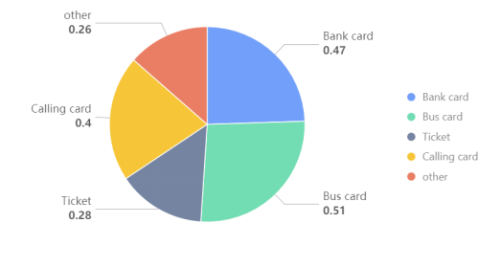
Fig.1 Use of different types of magnetic cards
2.As shown in Fig.2, we invited users to rate the importance of the characteristics that the magnetic card should have, the higher the score, the more important it is, out of 10 points. Among them, the versatility and durability score of the magnetic card is high, and the privacy and its convenient modification characteristics have also attracted people's attention.

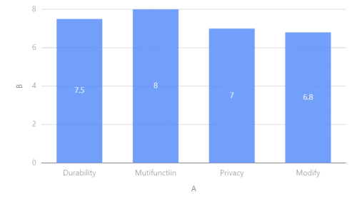
Fig.2 Performance importance
3.As shown in Fig.3, we interviewed the public about the expectations of magnetic cards, and more than half of them are very much looking forward to the advent of MFC.

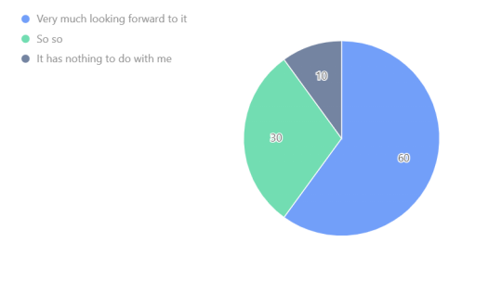
Fig.3 The user’s expectations

Step 2: Interpret raw data in terms of customer needs

MFC magnetic cards should be durable, that is, resistant to brakes, high temperatures, and not easy to break. The versatility of MFC also makes it carry a large amount of information from users, and users' personal privacy needs to be strongly protected. Nearly 60% of people are looking forward to the emergence of MFC, which has a good market prospect.

Step 3: Organize the needs into a hierarchy

Kano classification will be used here to classify user needs.
Must-haves | Must be versatile and versatile with a variety of magnetic card functions
Must-haves | Protect user privacy from disclosure
Delighters | Green
Delighters | Low price
Delighters | You can modify a certain range according to your preference
Linear Satisfiers | It has a variety of functions
 | durability
 | Easy to carry and not easy to lose
Neutrals | Beautiful shape

Step4: Establish the relative importance of the needs
We designed a survey which is used to rank customer needs. The results are as follows. Importance of feature on scale of 1-5.
- Versatile
- Durability
- Protect privacy
- It is convenient to modify personal information
- Environmentally friendly

Step5: Reflect on the results and process

We interviewed the target users, and mined the potential needs of users, in order to better develop the product, we can invite customers to participate in our product development, in order to timely and in-depth understanding of the core needs of users.

Concept Generation and Testing

Concept Generation
Clarify the problem
- Selection of circuit parameters:
Circuit parameters of course have a decisive impact on the performance of the produced MFC, which will affect the durability and cost of MFC. Examples include the choice of capacitance coefficient, the type of semiconductor field-effect transistor, and the choice of low-power memory.
- Size and shape:
The size and shape of the MFC card should conform to the overall structure of the hardware and consider the customer's needs to be convenient and easy to carry without being lost. Whether the material is plastic or semiconductor or metal, and the design of the product model, are a series of questions.
- APP development:
What functions should the functional software have to meet the needs of both customers and developers.
Search externally
As shown in Fig.4 and Fig.5, we did a survey on the product network. For the target user, we have counted the expected direction for the MFC card. It can be seen that the target users are more looking forward to durable and inexpensive products, and more looking forward to high-cost performance. At the same time, nearly two-thirds of users expect MFC cards to be as large as calling cards.
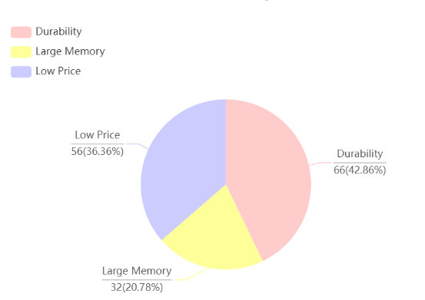
Fig.4 MFC Performance Expectations
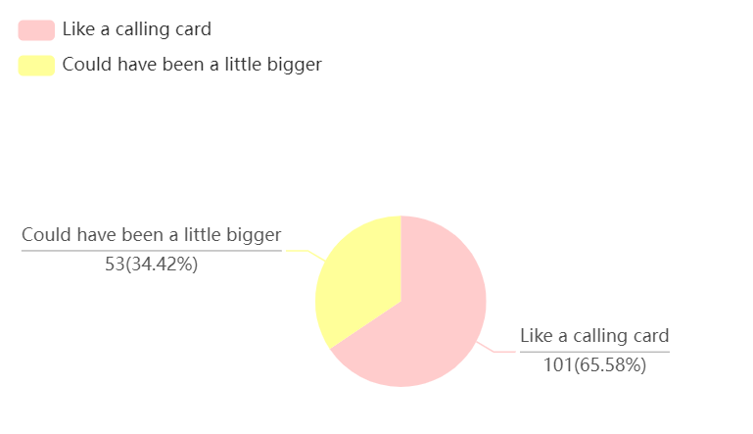
Fig.5 MFC Size Expectations

At the same time, we interviewed experts (Altium Designer, 2022) in related aspects, UFC technology is now more mature, MFC card is a multi-functional magnetic card developed on its basis, electrical parameters and size can be similar to today's UFC size, followed by magnetic cards, should pay more attention to durability and its degree of damage resistance (Mbalib, 2022).
We carefully interviewed 10 target users about the specific expectations of the relevant APP. To summarize as follows: APP should be able to provide multi-magnetic card functions personalized, users can add and modify the functions of magnetic cards, but also hope that APP is updated in time, developers can add new features in time, and secondly, personal privacy is well protected.
Search internally
1.Individual:
I personally believe that MFC should have a high-cost performance for both users and manufacturers and should match the existing magnetic card size to facilitate promotion, APP development should meet the diversified needs of users in a timely manner, while protecting user privacy.
Group member Boyang He added: As shown in Fig.6, Fig.7 and Fig.8, he gave the MFC shape design ideas. Purple is the bottom shell model shell of the design, orange is the battery card slot of the design, and green is the top model of the design.
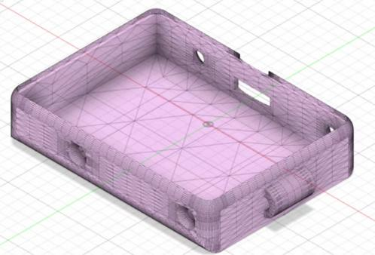
Fig.6 Bottom shell
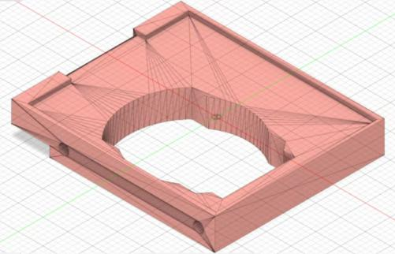
Fig.7 Battery card slot padding
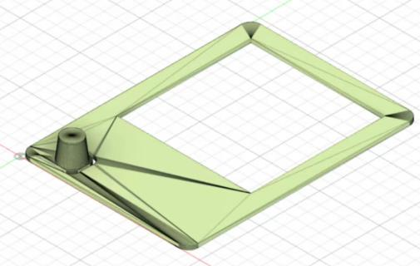
Fig.8 Top shell
2.Group:
In order to design an easy-to-use, low-cost and widely used MFC, our group discussed and designed an internal chip with the following circuit structure.
The following Fig.9 is our internal chip circuit structure, which is generally composed of capacitors, resistors, diodes, MOSFET-N, magnetic beads, switches, ED, and ST25DV16K-JFR6D3, STM32L051K8. Our core circuit components used STM32L051K8 to achieve low-power storage, and selected TPS61221DCKT as a boost regulator to improve the loss resistance of MFC. The chip will be superimposed between the housing and the padding, and the chip will be linked to the ink screen by a jumper.
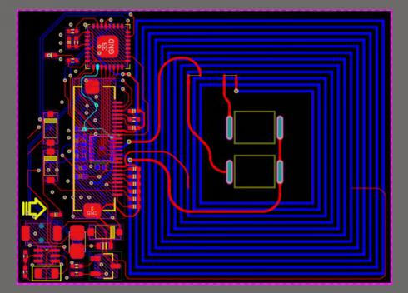
Fig.9 Internal chip circuit structure
Explore systematically
First of all, through the analysis of self-life examples, we reasonably push the card usage from the smaller group to the larger group and use a certain knowledge of supply and demand to preliminarily judge the personal design innovation point of the project card, and preliminarily simulate the technical feasibility and market productization feasibility of the project (Github, 2022).
Relying on the Internet platform and the actual survey, through the query of information, the actual questionnaire and the form, and with reference to the opinions of professionals, we have accurately screened out the product concepts with relevant needs, and cost-effective, portable and reliable.
Reflect on the solutions and process
We conducted market research, took in insider input, and used methods such as charts to gather useful information. Group member Zhang solved the problem of MFC size and shape, and the group discussed and selected the appropriate circuit components. However, there are still deficiencies, such as when searching externally, patent search is not applied, and there is no fine division of primary and secondary issues. Apply the learned concept generation method to complete this part, and the conclusion is accurate.

Concept Testing

Here we applied Ulrich and Eppinger's seven-step method for concept testing.
The purpose of the concept test is to better meet customer needs, projected sales volumes, and what we should do further. Therefore, we have chosen the product concept to be convenient and efficient and updatable as well as privacy protection.
According to the results of previous market research, the survey population is concentrated in commuters and students between the ages of 20 and 45(appendix, question1). Therefore, our research targets are mainly targeted at this group of people.
We conducted surveys in the form of online questionnaires and one-on-one interviews, collected and compiled survey results, and counted the results.
We showed it our product model diagram and explained the relevant functions, on the questionnaire we conducted a satisfaction test and other user ideas for the convenience and efficiency of the product concept, updatable and privacy, and collected other ideas of users, and showed our product concept to some users through WeChat, email and telephone and conducted interviews, hoping that they would give users' opinions.
We summarize the reactions of our customers. According to the questionnaire, more than half of the respondents are very much looking forward to the emergence of MFC (appendix, question7), more than 70% of users said they will buy MFC, and they have a 97% approval rate for our product concept. One-on-one interview we also summarized, users also hope that MFC-related APP can be beautiful and can be updated in a timely manner, but also expect MFC can be durable and moderately priced, with high-cost performance.
The results of the concept test show that the possible demand in the first year will be higher and the promotion rate will be large, which also shows that we have generated the correct product concept and gained the approval of users.
In the process of concept testing, we have conducted multi-angle thinking, taken a variety of means to conduct market research, in-depth understanding of customer needs, and further improved our product concept, but also pay attention to the discussion and reflection within the group.
Conclusion

Faced with the rigid demand of people for all kinds of cards, our group designed this multifunctional magnetic card based on NFC technology, which can be modified, read data and display content at any time.
In our research and development process, we went through four sections – opportunity identificaiton, mission statement, identification of customers need, concept generation and testing and finally prove the possibility of our product.
In the section of opportunity identification, we use the r-w-w framework to analyse the opportunity of our product. We find the market need of our product to be real and make sure our idea can achieve the product.
In the section of mission statement, we improved the product description and product objectives, and analyzed the product market, assumptions and constraints, and stakeholders one by one. While clarifying the goal, we will focus on products break through barriers and restrictions of related companies.
In the section of identification of customers need, we used the Ulrich and Eppinger’s five-step process. We supplement and reflect again according to the important functions of the investigator's feedback and be more confident in our product.
In the section of concept generation and testing, we search more information and made a concept testing. We also designed the rough paper of our product and made it into 3D model.
In the process of our development, we also find some difficulties. On the one hand, how to apply NFC technology into our product was a great difficulty. We searched quite a lot of data, and repeatedly modify the PC board, finally make the function smoothly. Another barrier must be the online contact. Without face to face communication, our group members cannot collaborate perfectly and had quite a lot variability in completion. Due to this fact, in the process of sorting out the work, we applied great time in unifying our work.
All in all, although our product is still in the development stage, the completeness of its functions and the hidden needs of the future market make us believe that we will get a great success.

List of References

- Wikipedia, (2022). Near-field communication. [Online]
Available at: https://en.wikipedia.org/wiki/Near-field_communication [Accessed 29th Apr. 2022].
- Wikipedia, (2022). 3D printing. [Online]
Available at: https://en.wikipedia.org/wiki/3D_printing [Accessed 25th Apr. 2022].
- Wikipedia, (2022). E Ink. [Online]
Available at: https://en.wikipedia.org/wiki/E_Ink [Accessed 25th Apr. 2022].
- Bilibili,(2022). Mini Smart NFC Card.[Online]
Available at: https://www.bilibili.com/video/BV1Cf4y1y7KT?spm_id_from=333.999.0.0 [Accessed 22nd Mar. 2022].
- Github, (2022).L-ink_Card.[Online]
Available at: https://github.com/peng-zhihui/L-ink_Card [Accessed 22nd Mar. 2022].
- Github,(2022). L-ink_Card.[Online]
Available at: https://github.com/simonire/L-ink_Card [Accessed 22nd Mar. 2022].
- Mbalib, (2022).NFC.[Omline]
Available at: https://wiki.mbalib.com/wiki/NFC [Accessed 25th Apr. 2022].
- Tom Igoe.Don Coleman, Brian Jepson.(2022). Start with PhoneGap and PhoneGap-NFC libraries.NFC: Arduino. Android And PhoneGap Near Field Communication(Chinese Edition). 53(2022), 21-44.
- Runoob,(2022). JS Tutorials[Online]
Available at: https://www.runoob.com/js/js-tutorial.html [Accessed 25th Apr. 2022].
- Altium Designer, (2022). OCTOPART.[Online]
Available at: https://www.altium.com.cn/octopart/overview [Accessed 25th Apr. 2022].
- Autodesk,(2022). LEARNING, TRAINING & CERTIFICATION[Online]
Available at: https://www.autodesk.com/training [Accessed 25th Apr. 2022].
- ST,(2022). Fitness Trackers.[Online]
Available at: https://www.st.com/en/applications/wearable/fitness-trackers.html [Accessed 25th Apr. 2022].

Appendix
MFC (Multi-Functional Magnetic Card) related survey
Question 1 What is your age group?
Option | Quantity | Proportion
15-20 | 51 | 59.3%
21-25 | 23 | 26.74%
25-30 | 1 | 1.16%
30-40 | 4 | 4.65%
Above 40 | 7 | 8.14%
Valid person times of this question | 86

Question 2 What is your gender?
Option | Quantity | Proportion
Male | 40 | 46.51%
Female | 46 | 53.49%
Valid person times of this question | 86

Question 3 What kind of magnetic cards do you use in your daily life?
Option | Quantity | Proportion
Credit Card | 40 | 46.51%
Bus card (Subway card) | 44 | 51.16%
Ticket card | 23 | 26.74%
Phonecard | 34 | 39.53%
Shopping card | 35 | 40.7%
Other | 23 | 26.74%
Valid person times of this question | 86

Question 4 Have you ever confused the type of magnetic card (e.g. mistook a bank card for a credit card)?
Option | Quantity | Proportion
Often | 15 | 17.44%
Occasionally | 38 | 44.19%
Never | 33 | 38.37%
Valid person times of this question | 86

Question 5 What do you think are the advantages of multifunctional magnetic cards?
Option | Quantity | Proportion
Green environmental protection | 47 | 54.65%
Easy to carry | 63 | 73.26%
Convenient life | 69 | 80.23%
Not easy to lose | 20 | 23.26%
Other | 1 | 1.16%
Valid person times of this question | 86

Question 6 Please rate the importance of the properties of the MFC card.
Properties | Average value of importance
Durability | 7.45
Multi-function | 7.64
Privacy | 7.01
Convenient modification | 6.41
 | Quantity:28.51; Average value:7.13

Question 7 Are you looking forward to the MFC card coming to life?
Option | Quantity | Proportion
Extremely expect | 49 | 56.98%
General expect | 32 | 37.21%
It's none of my business | 5 | 5.81%
Valid person times of this question | 86

Coursework Meeting Logbook

Members of the Team
Role | Given Name | Family name | BUPT number | QMUL number | Class Number
Leader | Yuchi | Wang | 2020213252 | 200978741 | 2020215108
Member | Junfeng | Zhang | 2020213271 | 200984328 | 2020215108
Member | Boyang | He | 2020213253 | 200977342 | 2020215108
Member | Hexi | Zou | 2020213272 | 200980010 | 2020215108
Member | Fei | Luo | 2020213279 | 200978279 | 2020215108
Project Title | Visual Erasable Card Based on NFC Technology
Date: 10th-Mar-2022
Meeting type: online meeting
Topics Discussed: Discuss design ideas for products to be developed.
Tasks to be achieved by next meeting: Complete the product idea design.
Next meeting (date/time): 18th-Mar.-2022

Date: 18th-Mar-2022
Meeting type: online meeting
Topics Discussed: Discuss how to write a mission statement for our product.
Tasks to be achieved by next meeting: Complete the writing and submission of product mission statement.
Next meeting (date/time): 29th-Mar.-2022

Date: 29th-Mar-2022
Meeting type: online meeting
Topics Discussed: Discuss how to collect users' opinions and demands on our multi-functional magnetic card by making a questionnaire.
Tasks to be achieved by next meeting: Prepare the questionnaire and complete the data collection, and write the Task3 report.
Next meeting (date/time): 12th-Apr.-2022

Date: 12th-Apr.-2022
Meeting type: online meeting
Topics Discussed: Discuss our product concepts and how to develop our product prototypes using Arduino.
Tasks to be achieved by next meeting: Completed the prototype development of magnetic card products on Arduino, and completed the simulation test experiments.
Next meeting (date/time): 26th-Apr.-2022

Date: 26th-Apr.-2022
Meeting type: online meeting
Topics Discussed: Summarize previous efforts, draw conclusions and evaluate the market potential of the product.
Tasks to be achieved by next meeting: Finish the writing of the conclusion, check and polish the previous content of the report, and complete the writing of the whole report.
Next meeting (date/time): 6th-May.-2022

Date: 6th-May.-2022
Meeting type: online meeting
Topics Discussed: Discuss the submission of the report and the division plan for the final video presentation.
Tasks to be achieved by next meeting: Complete submission of final report and preliminary plan for presentation of video.

